|  |
| --- |
| **POKOK BAHASAN 1** |
| **ELEMEN DASAR JAVA** |

**LEMBAR KERJA DAN TUGAS**

1. Program menggunakan type data Array dan Integer

public class Array1

{

public static void main (String[] args)

{

int[] i = new int[5];

i[0] = 200;

i[1] = 1234;

i[2] = 2347;

i[3] = 45;

i[4] = 9;

System.out.println("Juamlahelemen i = " + i.length);

System.out.println(" i[0] = " + i[0]);

System.out.println(" i[1] = " + i[1]);

System.out.println(" i[2] = " + i[2]);

System.out.println(" i[3] = " + i[3]);

System.out.println(" i[4] = " + i[4]);

}

}

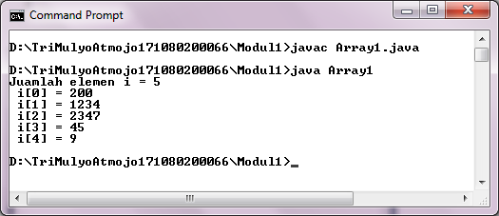

1. Program menggunakan type data Array dan String

public class Array7

{

public static void main (String[] args)

{

String[] s = {"aku", "kamu", "dia", "saya"};

System.out.println("Jumlah elemen s = " + s.length);

for (int i=0; i<s.length; i++)

System.out.println (s[i] + " panjang = " + s[i].length());

}

}

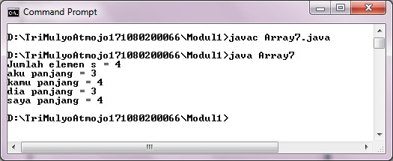

1. Program menggunakan type data integer

class AutoOperator

{

public static void main (String[] args)

{

int angka = 89;

int x, y, z;

int hitung = 0;

x = y = z = angka;

System.out.println ("angka = " + angka);

System.out.println ("x = " + x);

System.out.println ("y = " + y);

System.out.println ("z = " + z);

for (hitung=0; hitung<5; hitung ++)

System.out.println (hitung);

}

}

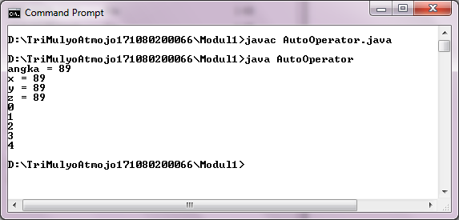

**TUGAS**

1. Buatlah program java untuk menampilkan biodata pribadi anda (min 7 kategori)!

public class Tugas1Biodata {

public static void main (String argv []) {

System.out.println();

System.out.println (" BIODATA ");

System.out.println();

System.out.println ("Nim : 161080200066") ;

System.out.println ("Nama : Tri Mulyo Atmojo");

System.out.println ("Kelas : 3A1") ;

System.out.println ("Jurusan : Informatika") ;

System.out.println ("TTL : Purworejo, 02 Desember 1998") ;

System.out.println ("Jenis Kelamin : Laki-Laki") ;

System.out.println ("Alamat : Kwadengan Timur, Kelurahan Lemah Putro") ;

System.out.println ("Status : Mahasiswa") ;

System.out.println();

}

} 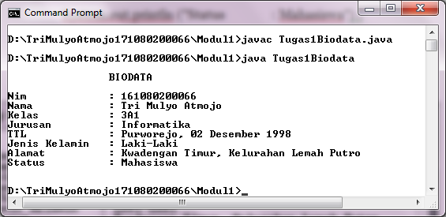

1. Buatlahprogram untuk menghitung persamaan berikut ini. Jika f(x) = 2x4 + 5x3 + 6x2 – 4x – 27, tentukan berapa nilai f(x) bila x = 8.

importjava.util.Scanner;

public class Tugas2Mpersamaan {

public static void main (String argv[]) {

Scanner input = new Scanner (System.in);

intx,y;

System.out.println("Rumus = 2x^4+5x^3+6x^2-4x-27");

System.out.print("Masukkannilai x : "); x=input.nextInt();

y = (2*x*x*x*x)+(5*x*x*x)+(6*x*x)-(4*x)-27;

System.out.println("Nilai f(x) : "+y);

}

}

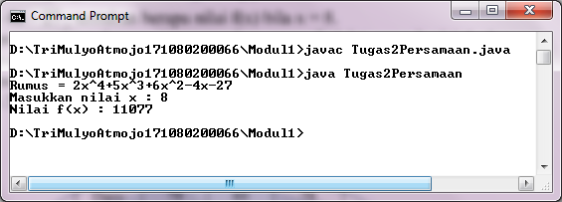

1. Buatlah program java dengan menggunakan array dari int yang berisi 6 element, kemudian cetak masing – masing element tersebutpadalayar monitor.

public class Tugas3Array {

public static void main (String argv[]) {

intMyArr[];

MyArr = new int [6];

MyArr[0] = 1;

MyArr[1] = 2;

MyArr[2] = 3;

MyArr[3] = 4;

MyArr[4] = 5;

MyArr[5] = 6;

System.out.println ("Elm1="+MyArr[0]+" Elm2="+MyArr[1]+" Elm3="+MyArr[2]+" Elm4="+MyArr[3]+" Elm5="+MyArr[4]+" Elm5="+MyArr[5]);

}

}

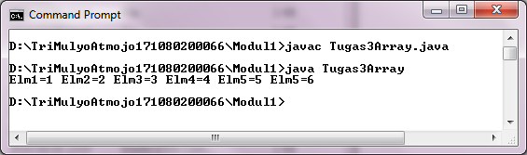

1. Denganmenggunakan array 2 dimensi, buatlah program yang menghitung nilai akhir dari 3 mahasiswa dengan aturan :

Na = 0.35*UTS +0.45*UAS+0.2*Tugas ;

|  |  |  |  |
| --- | --- | --- | --- |
| **Nama** | **UTS** | **UAS** | **Tugas** |
| Udon | 80 | 85 | 90 |
| Dany | 79 | 80 | 78 |
| Rissa | 90 | 97 | 89 |
| Tino | 90 | 88 | 89 |
| Flo | 90 | 67 | 99 |

public class Tugas4Array2D {

public static void main (String argv[]) {

double n;

String nama[]={"Udon", "Dany", "Rissa", "Tino", "Flo"};

double uts[]={80,79,90,90,90}, uas[]={85,80,79,88,67}, tugas[]={90,78,89,89,99};

for (int i=0; i<5; i++) {

System.out.print("Nilai "+nama[i]+"=");

n=0.35*uts[i]+0.45*uas[i]+0.2*tugas[i];

System.out.println("UTS:"+uts[i]+", UAS:"+uas[i]+", Tugas:"+tugas[i]+"NilaiAkhir:"+n);

}

}

}

